Problem 1

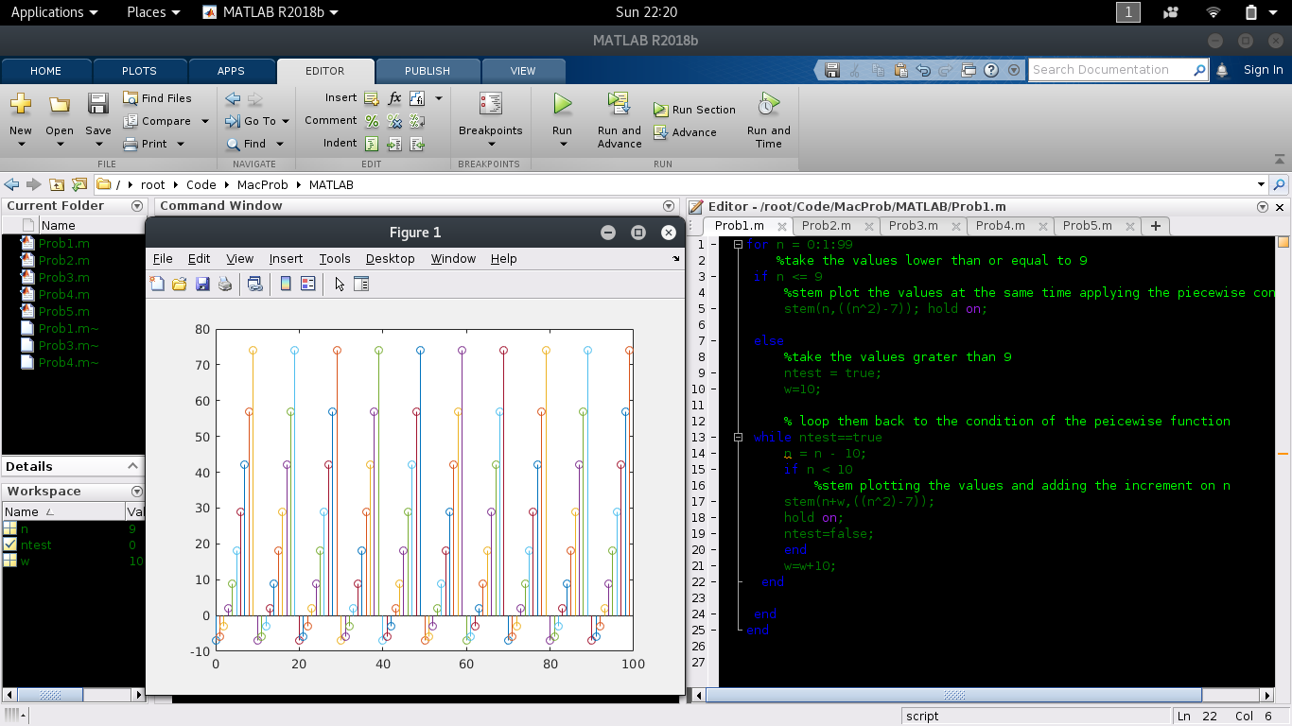

Problem 2

(Positive Testing – unit circle)

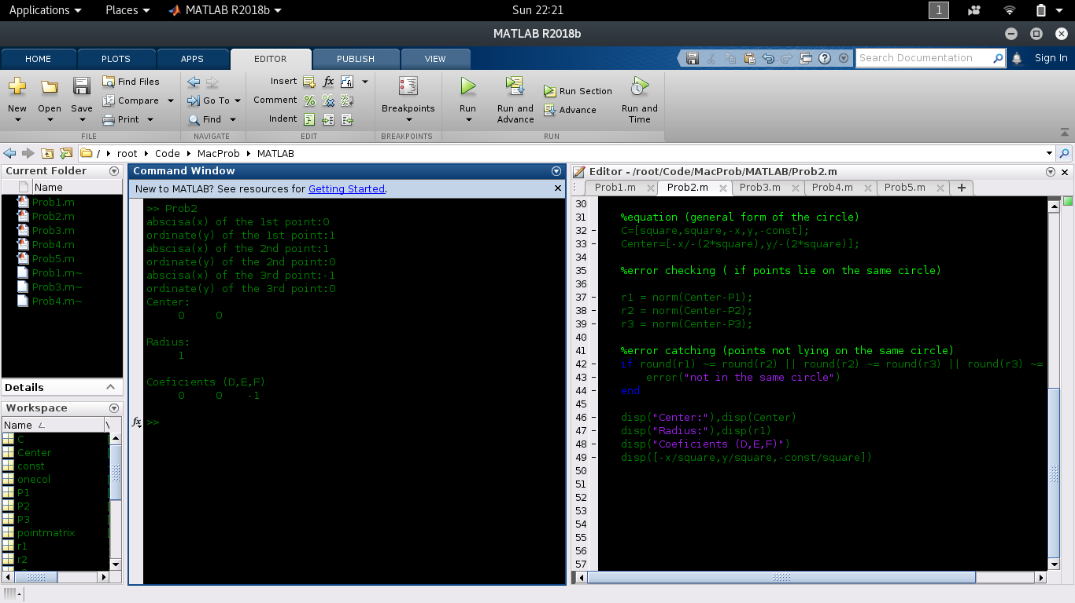

Negative Testing (points not on the same circle)

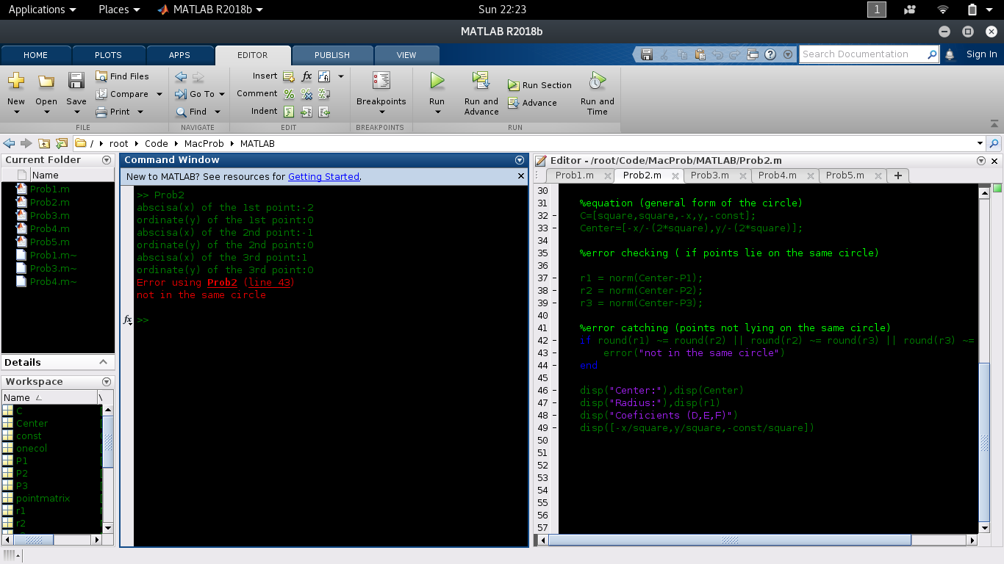

Problem 3

Positive Testing(x = [1,2,3,4,5] y = [6,7,8,9,10])

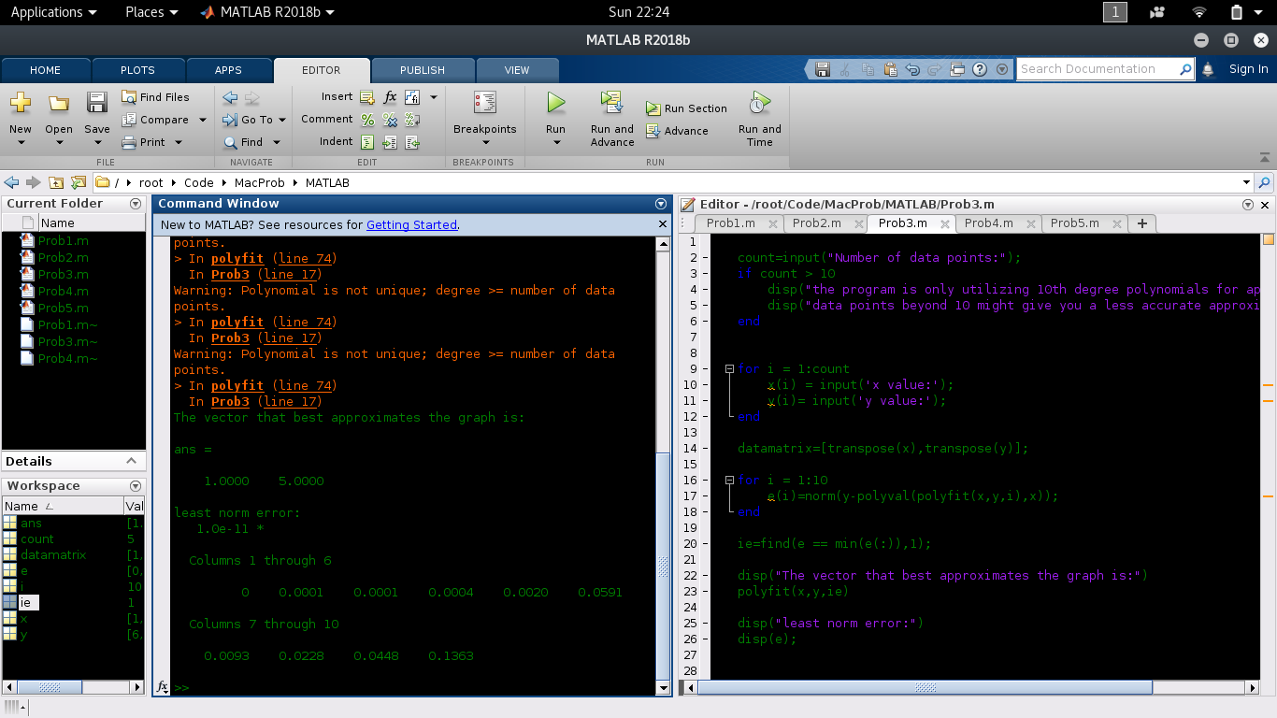

Negative Testing(input letters)

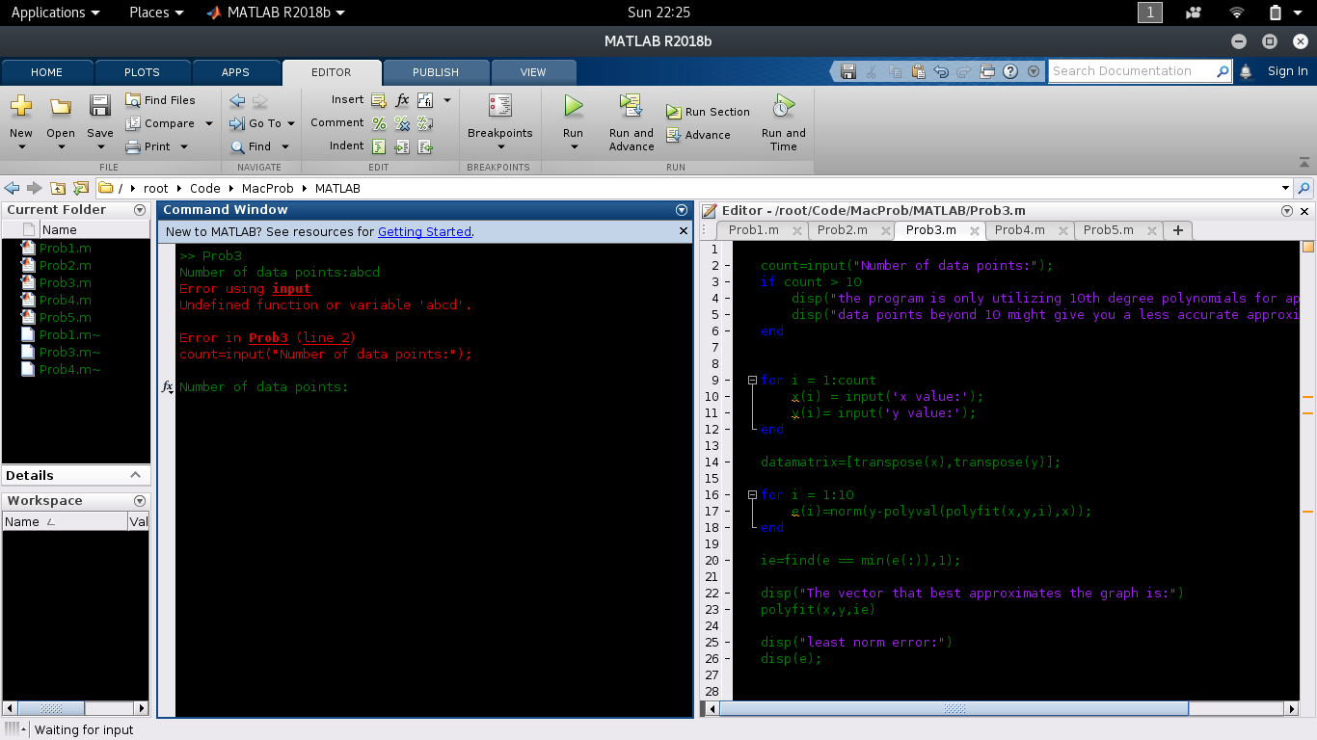

Problem 4

Positive testing( hi=60 , theta=60, mag = 60 ax=0 ay=-9.8)

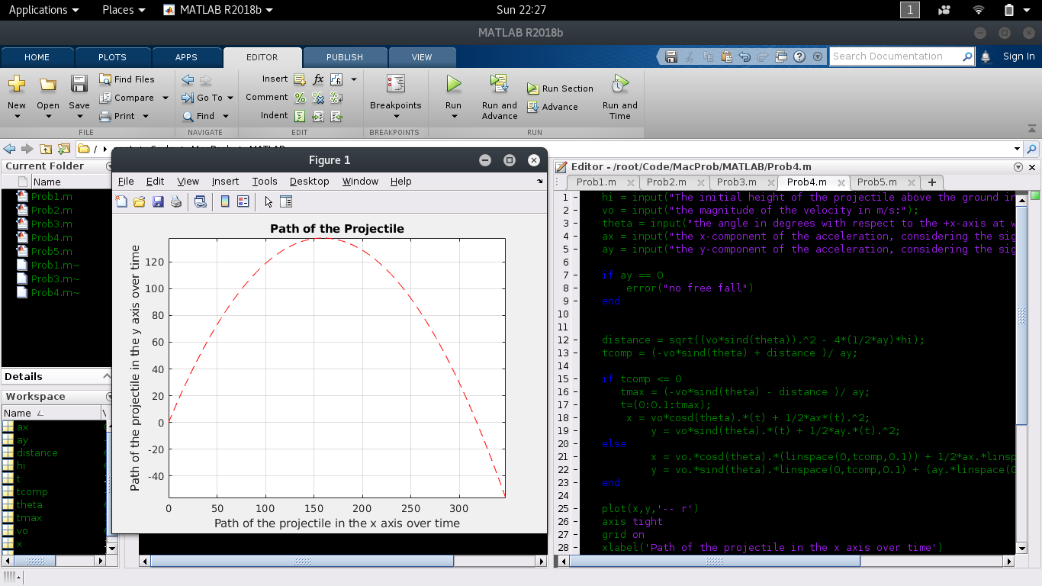

Negative Testing ( Ay = 0)

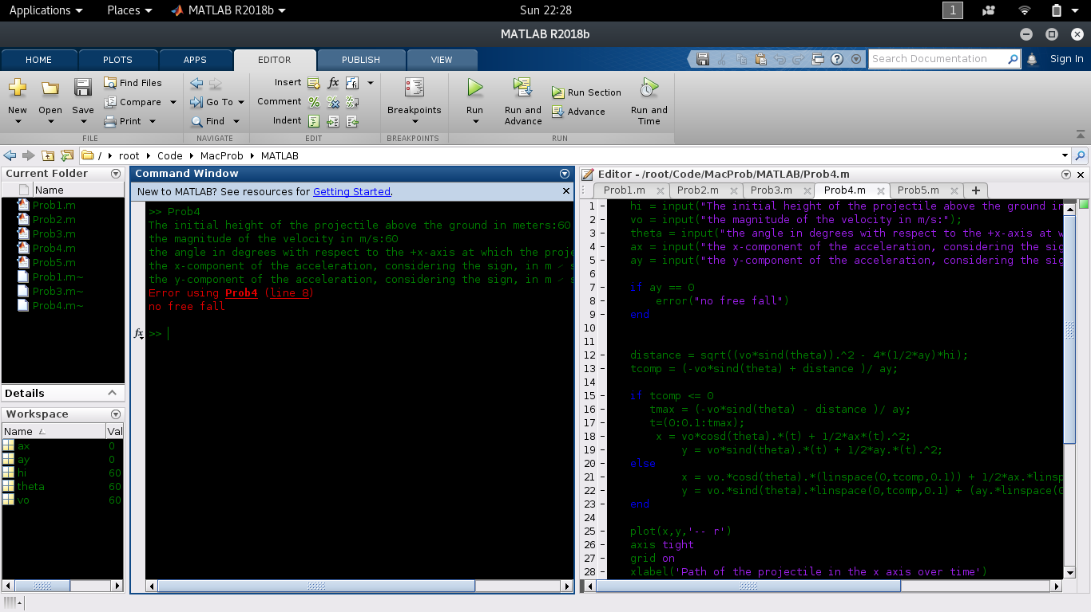

Problem 5

